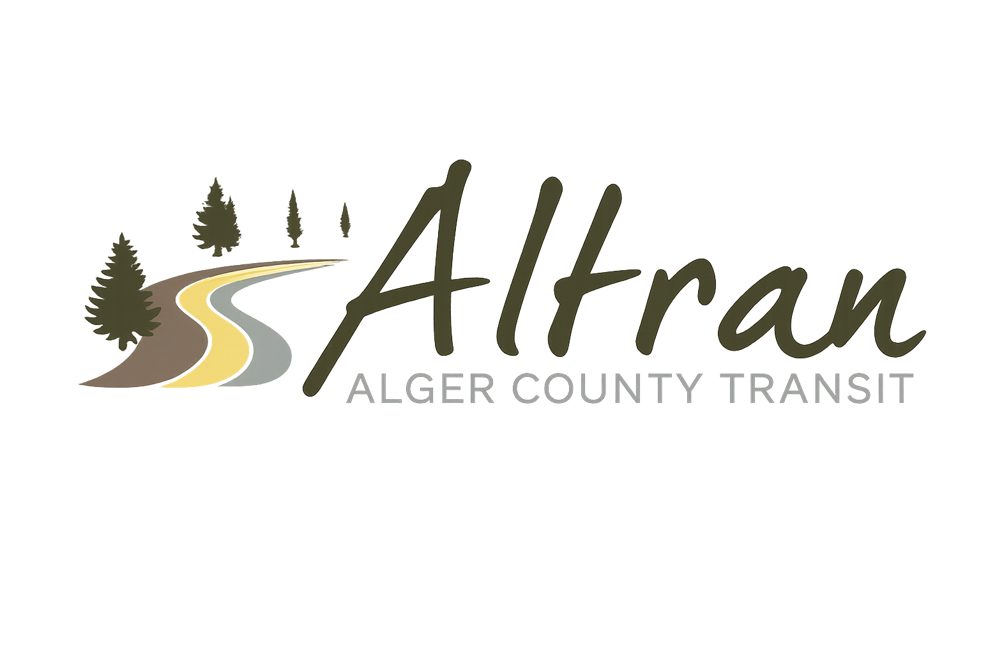


ALTRAN OFFICE
Munising, Michigan
Tuesday, September 22nd, 2026 11:00 a.m.
- Call to Order
- Roll Call
- Approval of Agenda
- Public Comment for agenda items only-2 (two) minute limit
- Approval of Minutes- August
- Approval of Expenditures- August
- Approval of Financial Report- August
- Director’s Report
  - Wash bay Upgrades
  - Security Upgrades
  - RTF Projects
  - Dispatch Software Update
  - Administration Email Change Over
  - Lift Ramps
  - Q3 OAR
  - Marquette Beerfest Shuttle
  - Ice Fest
  - Superior Street Station Fall Decorations
- Correspondence
- Committee Reports
- Old Business
  - Park Shuttle Update
- New Business
- Public Comments-2 (two) minute limit
- Board Comments
- Next Meeting Date- October 13th, 2026-11:00 a.m.
- Adjournment

