
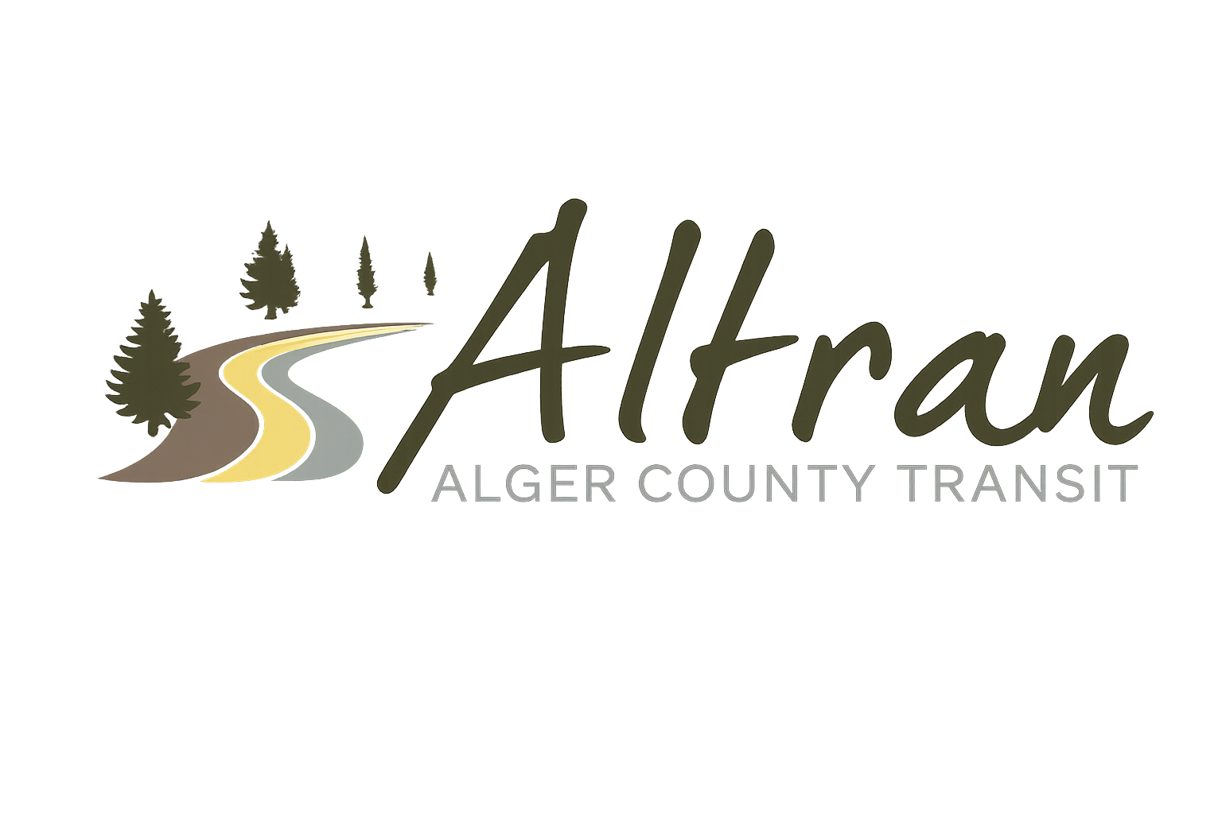

ALTRAN OFFICE
Munising, Michigan
Tuesday, July 14th, 2026 11:00 a.m.
- Call to Order
- Roll Call
- Approval of Agenda
- Public Comment for agenda items only-2 (two) minute limit
- Approval of Minutes- June
- Approval of Expenditures- June
- Approval of Financial Report- June
- Director’s Report
  - OAR
  - Annual Application
  - Triennial Compliance Review
  - P15 Project
  - Parking Lot
  - Mural
  - Employee Meeting
  - SSS updates
  - Open House
  - Fourth of July Parade
- Correspondence
- Committee Reports
- Old Business
  - Dispatch Software
- New Business
  - Employee Policy Updates
  - Account Changes
- Public Comments-2 (two) minute limit
- Board Comments
- Next Meeting Date- August 11th, 2026-11:00 a.m.
- Adjournment

