
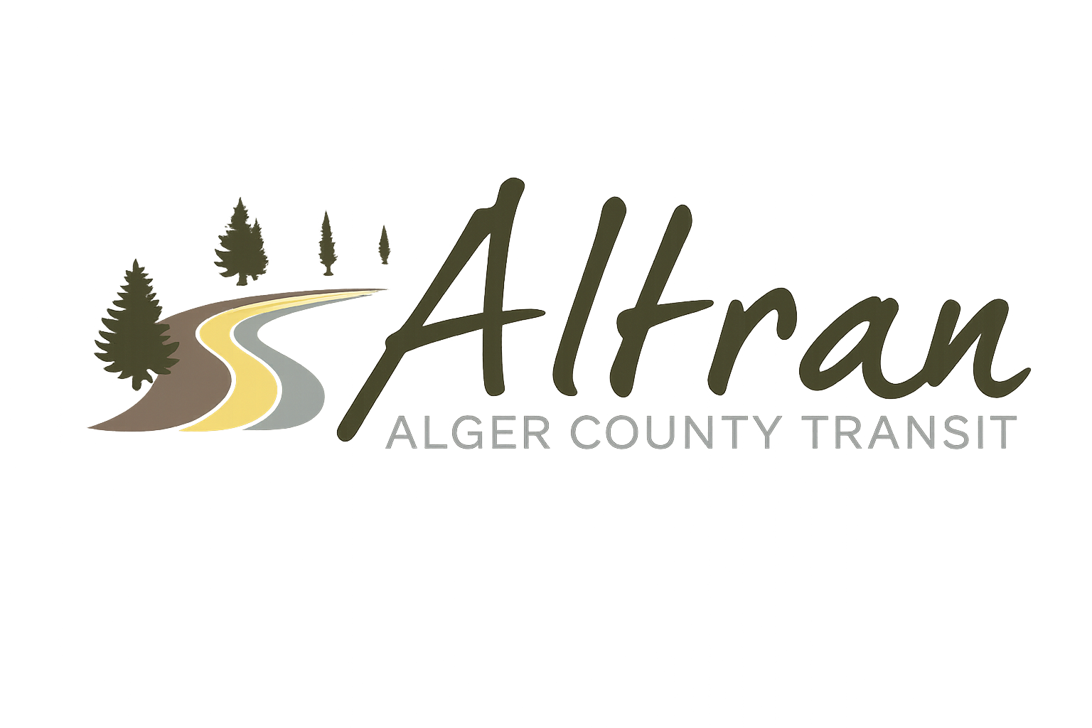

ALTRAN OFFICE
Munising, Michigan
Tuesday, May 12th, 2026 11:00 a.m.
- Call to Order
- Roll Call
- Approval of Agenda
- Public Comment for agenda items only-2 (two) minute limit
- Approval of Minutes- April
- Approval of Expenditures- April
- Approval of Financial Report- April
- Director’s Report
  - Dispatch software
  - Meeting with Sault tribe
  - Compliance review
  - Millage update
  - Millage signs
  - Billboard signs
  - Superior station signs
  - Open house
  - Backpackers
  - Summer hires
- Correspondence
- Committee Reports
- Old Business
- New Business
- Public Comments-2 (two) minute limit
- Board Comments
- Next Meeting Date- June 9th, 2026-11:00 a.m.
- Adjournment

