
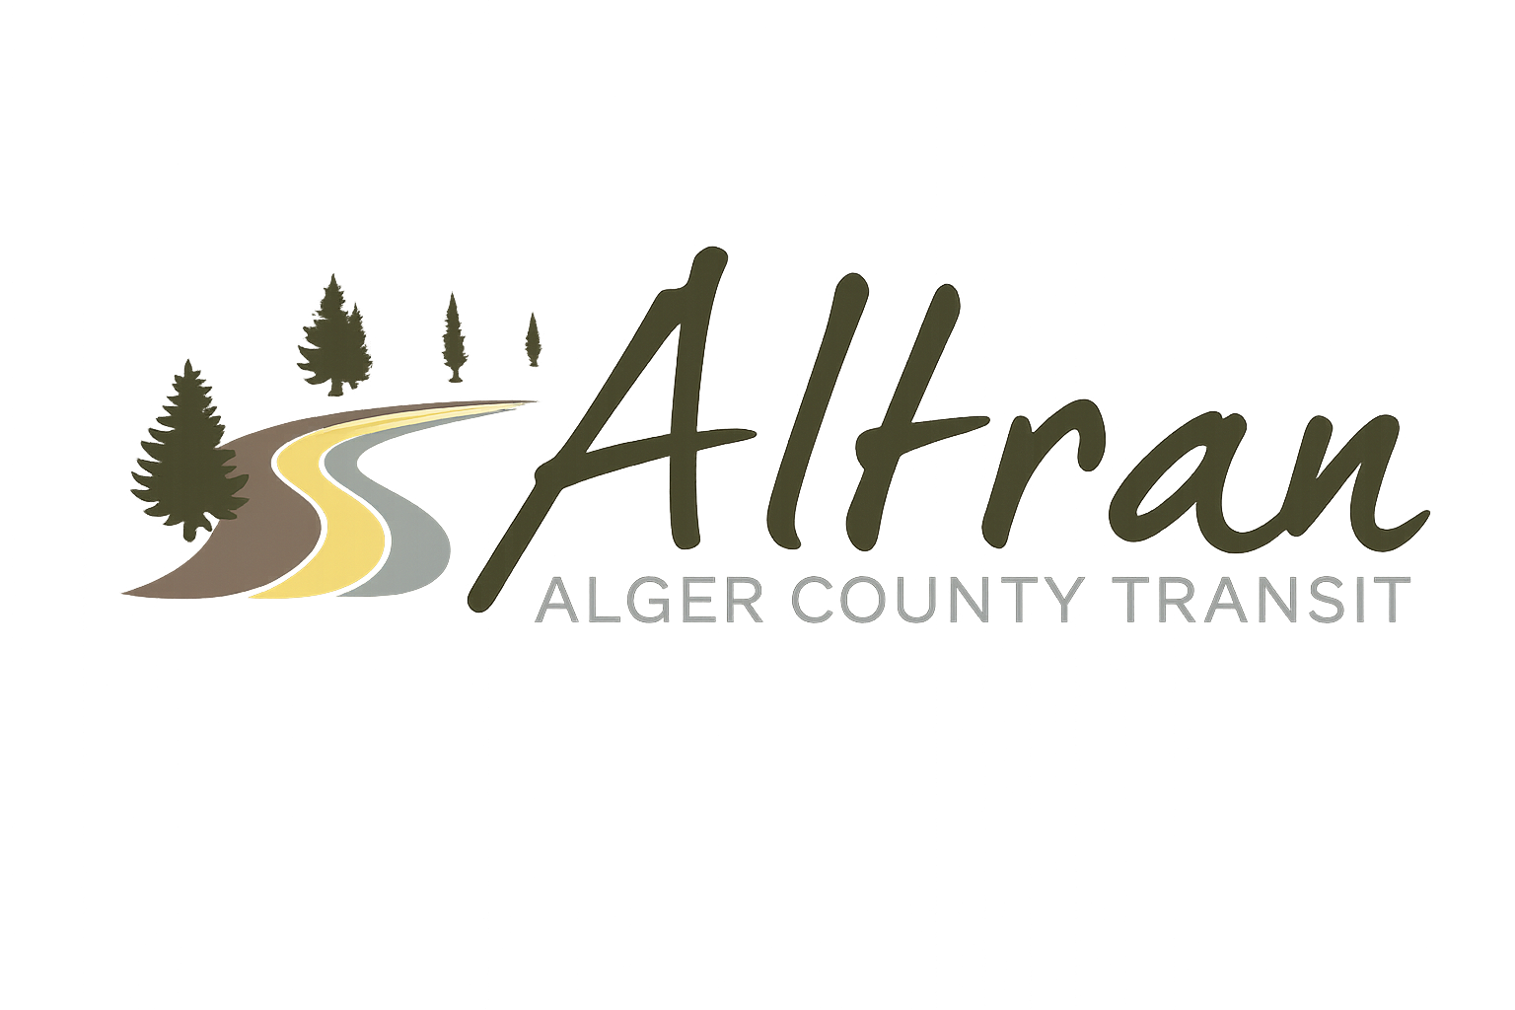

ALTRAN OFFICE
Munising, Michigan
Tuesday, April 21st, 2026 11:00 a.m.
- Call to Order
- Roll Call
- Approval of Agenda
- Public Comment for agenda items only-2 (two) minute limit
- Approval of Minutes- March
- Approval of Expenditures- March
- Approval of Financial Report- March
- Director’s Report
  - Millage Update
  - MPTA Annual Rural Transit Managers Workshop
  - DDA Grants
  - P15 Project Update
  - RTF Update
  - P20 Project Update
  - Diane Kienitz Retirement
  - Grover Nix Mechanic License
  - MPTA NOFO Training
  - MPTA Vehicle Maintenance Seminar
- Correspondence
  - Mike Anderson Audit
  - Paige Eiseman Facebook
- Committee Reports
- Old Business
  - FMCSA
  - CHRISS
  - PSB CC
- New Business
- Public Comments-2 (two) minute limit
- Board Comments
- Next Meeting Date- May 12th, 2026-11:00 a.m.
- Adjournment

