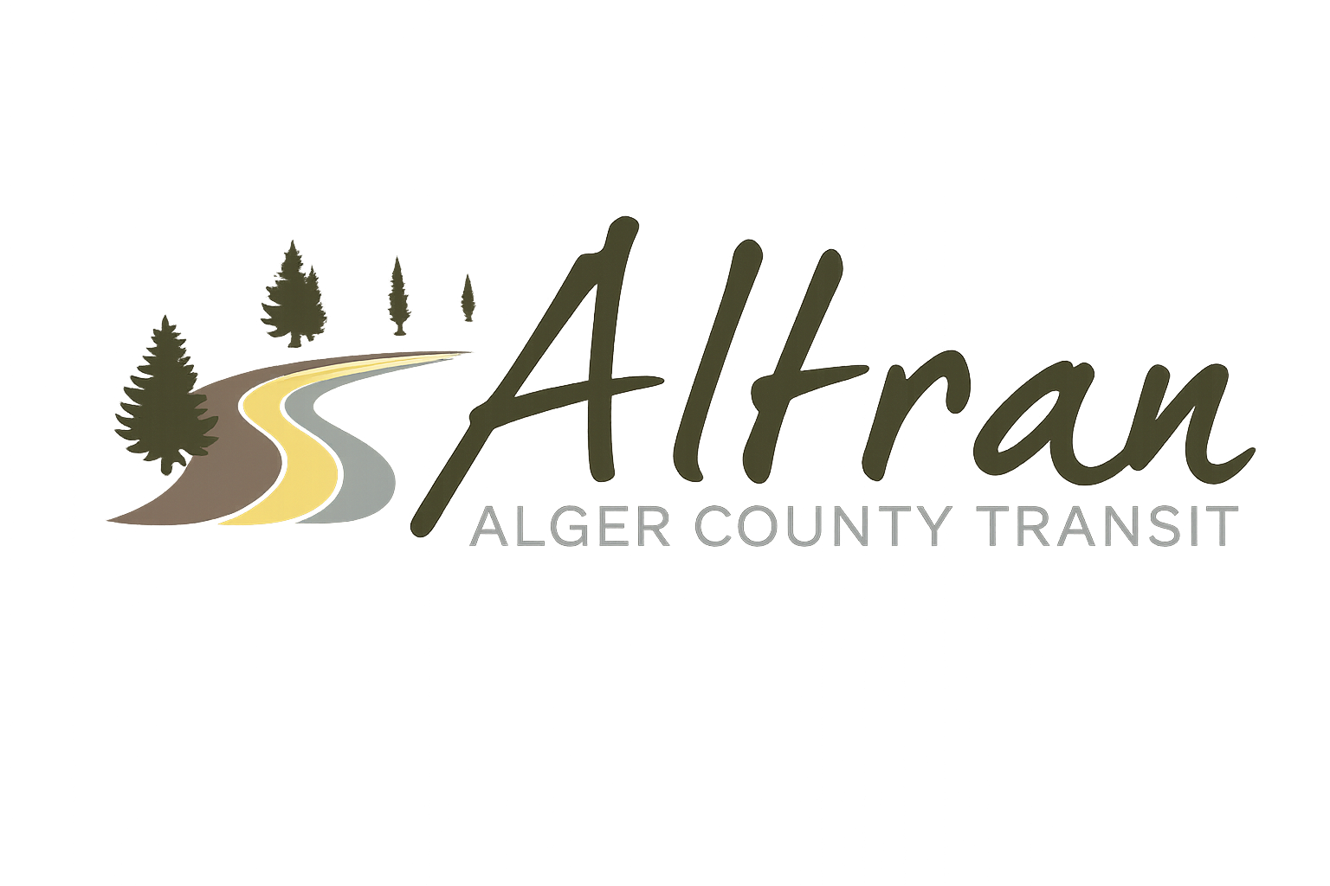


ALTRAN OFFICE
Munising, Michigan
Tuesday, March 10th, 2026 11:00 a.m.
- Call to Order
- Roll Call
- Approval of Agenda
- Public Comment for agenda items only-2 (two) minute limit
- Approval of Minutes- February
- Approval of Expenditures- February
- Approval of Financial Report- February
- Director’s Report
  - Millage language
  - Audit
  - Testimonials
  - MPTA
  - OAR
  - Ice fest
  - Bus wraps
  - Trenary outhouse races
  - Employee handbook updates
  - Hiring for summer
  - Legislative day
- Correspondence
  - Facebook
- Committee Reports
- Old Business
- New Business
  - CHRISS
  - Verified First
  - FMCSA
- Public Comments-2 (two) minute limit
- Board Comments
- Next Meeting Date- April 14th, 2026-11:00 a.m.
- Adjournment

