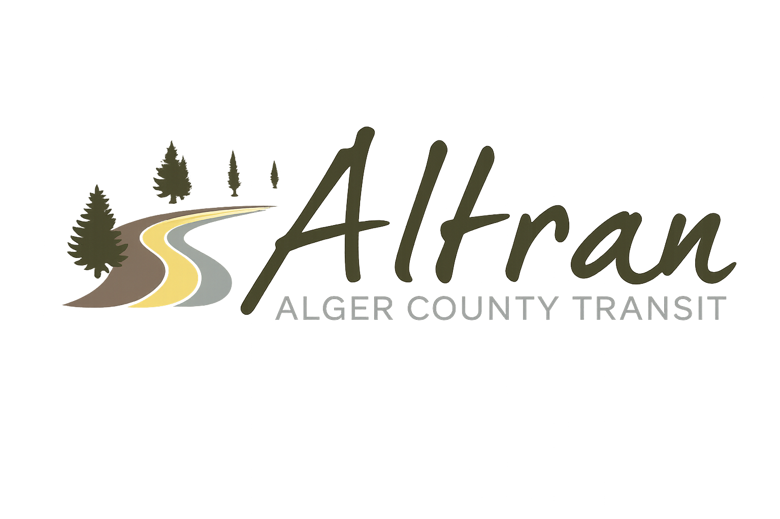


ALTRAN OFFICE
Munising, Michigan
Tuesday, February 10th, 2026 11:00 a.m.
- Call to Order
- Roll Call
- Approval of Agenda
- Public Comment for agenda items only-2 (two) minute limit
- Approval of Minutes- January
- Approval of Expenditures- January
- Approval of Financial Report- January
- Director’s Report
  - Ice fest starts the 11th – 15th
  - Building upgrade delays
  - Audit still delayed
  - Annual application FY27 has been submitted
  - Bus wraps
  - Backpacker reservation portal online
  - Grand Marais Chamber of Commerce
  - Good Sheperd field trip to Marquette
  - Trenary Outhouse races
  - Legislative day at the Capital March 11th
- Correspondence
- Committee Reports
- Old Business
- New Business
  - Changing email address domain to @Altranbus.com
- Public Comments-2 (two) minute limit
- Board Comments
- Next Meeting Date-March 10th, 2026-11:00 a.m.
- Adjournment

