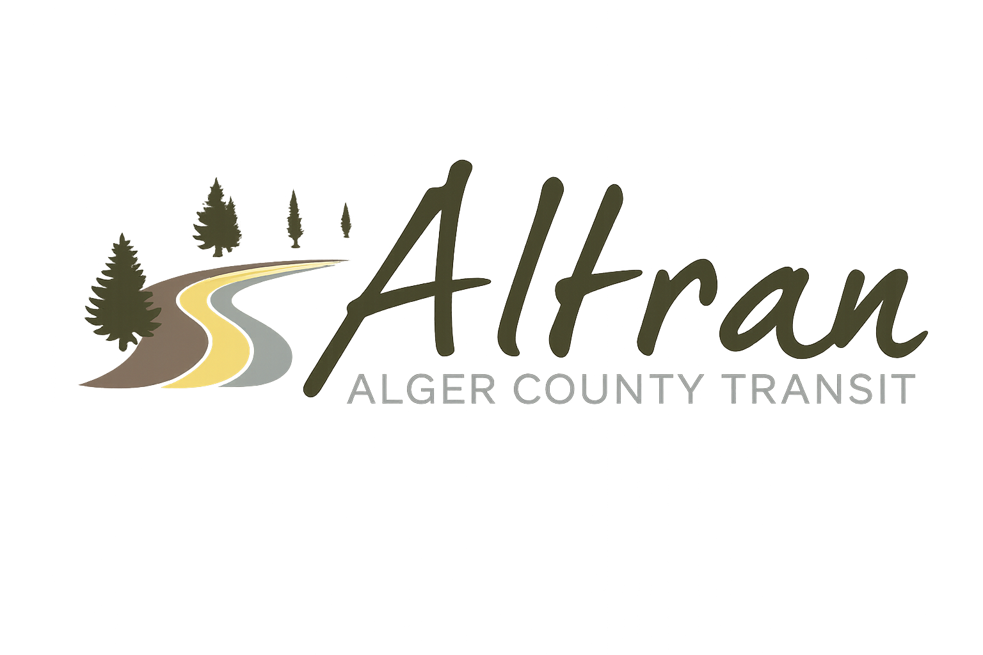


ALTRAN OFFICE
Munising, Michigan
Tuesday, January 20th, 2025 11:00 a.m.
- Call to Order
- Roll Call
- Approval of Agenda
- Public Comment for agenda items only-2 (two) minute limit
- Approval of Minutes- December
- Approval of Expenditures- December
- Approval of Financial Report- December
- Director’s Report
  - Lac meeting
  - Employee handbook update
  - Backpacker route alteration
  - Public notice
  - Munising Beacon
  - Mather and Good Sheperd school tour
  - Ice fest
  - Outhouse races
  - Chatham fair
- Correspondence
- Committee Reports
- Old Business
  - Millage
- New Business
- Public Comments-2 (two) minute limit
- Board Comments
- Next Meeting Date-February 10th, 2025-11:00 a.m.
- Adjournment

