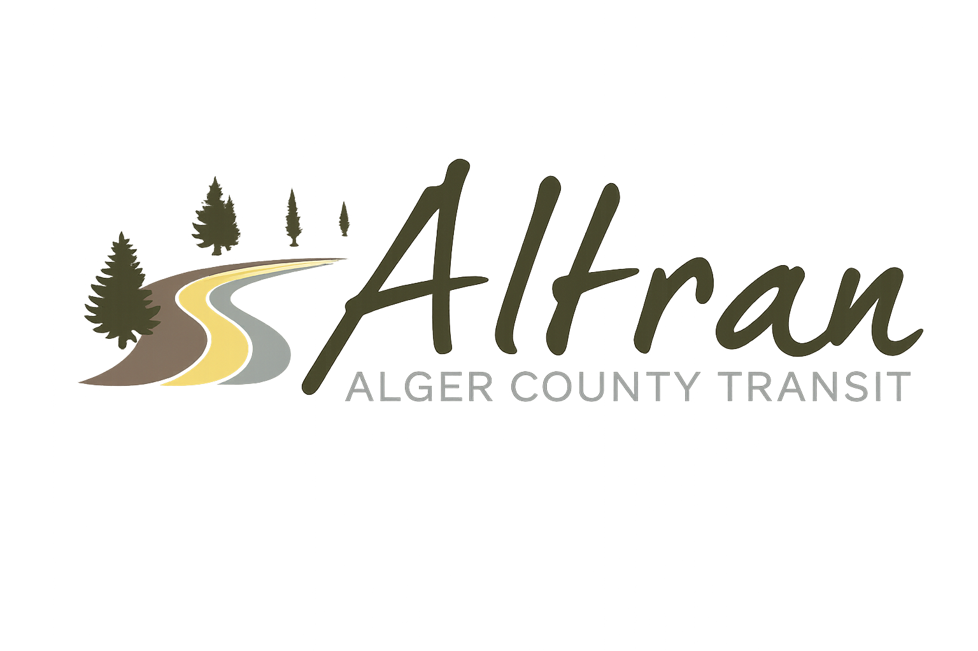


ALTRAN OFFICE
Munising, Michigan
Tuesday, December 23rd, 2025 11:00 a.m.
- Call to Order
- Roll Call
- Approval of Agenda
- Public Comment for agenda items only-2 (two) minute limit
- Approval of Minutes- October & November
- Approval of Expenditures- October & November
- Approval of Financial Report- October & November
- Director’s Report
  - Putvin bus wrap completed
  - Next wraps are COA, Veterans affairs, The getaway
  - New operations manager, Paige Eiseman
  - LAC meeting in January
  - Added new route for backpackers and price increase
  - Anderson Tackman delayed
  - Next years board meeting dates
  - Christmas light tours
  - Christmas party
  - Krist oil
  - Amex
  - Michigan Municipal Risk Management
- Correspondence
- Committee Reports
  - Finance report
  - Budget FY27
- Old Business
- New Business
- Public Comments-2 (two) minute limit
- Board Comments
- Next Meeting Date-January 13th, 2025-11:00 a.m.
- Adjournment

